

**KLE SOCIETY'S CHIDANAND.B. KORE POLYTECHNIC, CHIKODI KARNATAKA 2024-2025**

**DEPARTMENT OF COMPUTER SCIENCE & ENGINEERING**

**A SYNOPSIS REPORT ON “Café Management System”**

Submitted for partial fulfilment of the requirements of the award of the

# DIPLOMA IN COMPUTER SCIENCE & ENGINEERING

UNDER THE GUIDENCE OF

Miss. Sarita Khot(Lecturer)

Mr. Rajashekar Bendawade(Lecturer)

A

Synopsis

Submitted by:-

**Tanushree Muddappagol 339CS22055**

**Vaishnavi Kalal 339CS22057**



**KLE SOCIETY'S CHIDANAND.B.KORE POLYTECHNIC, CHIKODI**

DEPARTMENT OF COMPUTER SCIENCE & ENGINEERING

# CERTIFICATE

Certified that this Synopsis report entitled “CAFÉ MANAGEMENT SYSTEM” which is submitted by Miss. Vaishnavi Kalal Reg No. 339CS22057, a bonafide student of Chidanand B Kore Polytechnic in Partial fulfilment for the award of Diploma in Computer Science & Engineering during the year September 2024-25 is record of student own work carried out under my/our guidance. It is certified that all corrections/suggestions. The indicated for internal Assessment have been incorporated in the Report and one copy of being deposited in polytechnic library.

The Synopsis report has been approved as it satisfies the academic requirements in respect of Project work prescribed for the said diploma. It is further understood that by this certicate the undersigned do not endorse or approve any statement made, opinion expressed or conclusion drawn there in but approve the project only for purpose for which it is submitted.

Guide Head of Department Principle

Name and Signature of Examiner

1

2

**Table Content**

|  |  |  |
| --- | --- | --- |
| **SL.no** | **Content** | **Page no** |
| 1 | Introduction |  |
| 2 | Abstract of Project |  |
| 3 | Literature Survey |  |
| 4 | Objective of the Project |  |
| 5 | Scope of the Project |  |
| 6 | System Design |  |
| 7 | Input / Output Requirement |  |
| 8 | Hardware and Software Requirement |  |
| 9 | E-R Diagram(use case diagram) |  |
| 10 | Advantages and Disadvantages |  |
| 11 | Future Scope of the Project |  |
| 12 | Conclusion |  |
| 13 | Reference of Bibliography |  |

## Abstract of Project

The main aim of science technology is to understand natural event. We feel this event with our mind, which is main part of our body. Computer is also gift of science, which also works like a brain, but the manner speed at so many other properties are much more than a men’s brain.

Modern age is an age of computer. Computer has just become a part of our life. The computer education in India was started in somewhere in sixties. Now with the advent of microcomputer, it has become possible to have mass education in this field. The major advantage of computers is speed which calculated the relative of output comes. Computer can store much information and solve our problem within.

So, keeping these things in views, I have computerized my small project work “**Café Management System”**.

## Literature Survey

A literature review evaluates the information within any published literature related to the topic or research question you choose. The literature review is meant to analyze the published literature related to your topic. A literature review reflects upon what has already been written about (methodical or theoretical), what the existing literature contributes to the field, and how your topic corresponds with the literature. If your topic exposes a gap in the existing research in your field, make note of that in the literature review.

## OBJECTIVE

The objectives of the system are-

* To develop a web-based system that will help to manage the cafe information about the cafe.
* It takes the suggestion from the user.
* Simplify contact and support access.
* It takes less processing time.
* To provide the fresh coffee and healthy product to the people.
* Facilitate easy order tracking.
* Offer a user-friendly interface.

## SCOPE

* **Streamlined Operations:** Automates order processing, payment handling, and inventory management.
* **Improved Efficiency:** Reduces manual tasks and minimizes errors in daily operations.
* **Enhanced Customer Experience:** Speeds up service and provides a seamless ordering process.
* **Data Insights:** Offers analytics for menu optimization, pricing strategies, and inventory control.
* **Cost Reduction:** Minimizes waste and controls inventory, leading to better profit margins.
* **Scalability:** Easily adaptable to café growth and expansion.
* **Customer Engagement:** Facilitates feedback collection and loyalty programs.

## System Design

**The systems development life cycle (SDLC)**

The system development life cycle (SDLC), also referred to as the application development life cycle, is a term used in systems engineering, information systems and software engineering to describe a process for planning, creating, testing, and deploying an information system. The systems development lifecycle concept applies to a hardware and software configurations, as a system can be composed of hardware only, software only, or a combination of both.

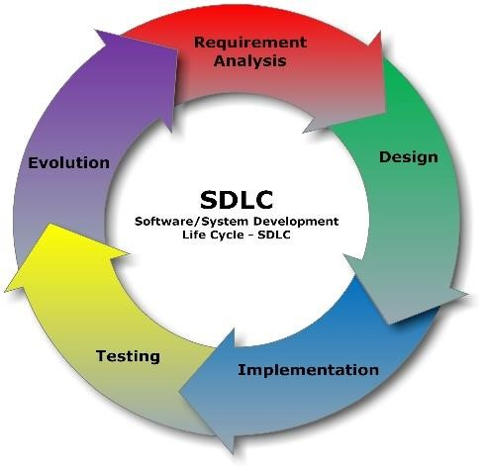

**Planning and Requirement Analysis**

Requirement analysis is the most important and fundamental stage in SDLC. It is performed by the senior members of the team with inputs from the customer, the sales department, market surveys and experts in the industry. This information is then used to plan the basic project approach and to conduct product feasibility study in the economic, operational, and technical areas.

**Defining Requirements**

Once the requirement analysis is done the next step is to clearly define and document the product requirements and get them approved from the customer or the market analysis. This is done through (SRS) Software Requirement Specification document which consists of all the product requirements to be designed and developed during the project life cycle.

step is to clearly define and document the product requirements and get them approved from the customer or the market analysis. This is done through (SRS) Software Requirement Specification document which consists of all the product requirements to be designed and developed during the project life cycle.

## Hardware / Software Requirement (minimum)

**Hardware:**

* C.P.U : Core 2 Due
* Motherboard : Intel chip/original based Pentium pc
* RAM : 1 GB
* Monitor : colour(SVGA)
* Resolution : 800*600
* HDD : 160 GB

**Software:**

* Operating system : windows
* IDE : Notepad or Dream viewer
* Design : Photo Shop
* Server : Xamp Server
* Browser : Preferred Chrome

**Input Requirements**:-

**Homepage:**

* User clicks on navigation links (e.g., Menu, Order, Contact Us, Blog).
* User preferences or previous orders (if logged in).

**Menu Page:**

* User selection of menu items (e.g., Pizza, Burger, Cold Coffee, Toast).
* Add to Cart button clicks.

**Add to Cart:**

* User adds items to the cart from the menu.
* Remove item from cart option.

**Contact Us Page:**

* User inputs name, email, and message in the contact form.

# Output Requirements:-

**Homepage:**

* Display of menu categories or special offers.
* User-specific greetings or notifications (if logged in).

**Menu Page:**

* Display of available menu items with descriptions and prices.
* Confirmation message after adding items to the cart.

**Add to Cart:**

* Updated cart with selected items and total price.
* Confirmation message for items added or removed.

**Contact Us Page:**

* Display of contact information (e.g., phone number, email).
* Map showing café location (if applicable).

**Entity Diagram:**

The Entity Diagram was originally proposed by Peter for the design of the relation data base system, components is identified for the ERD; data objects, attributes, relationships and various types of indicators. The primary purpose of the Entity Diagram is, was originally proposed by Peter Chen for the design of Relational Database System. The Entity model is extremely useful in mapping and interactions of real world enterprise.

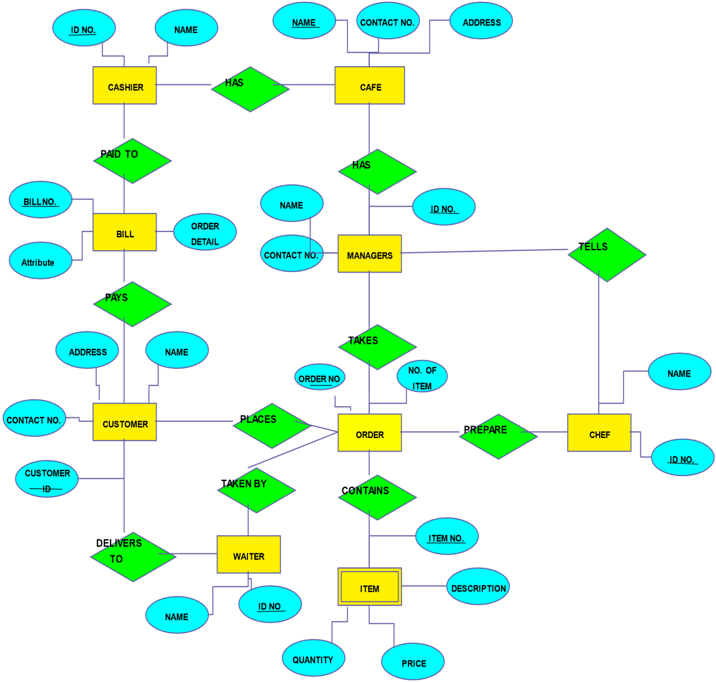

**UML Diagram:**

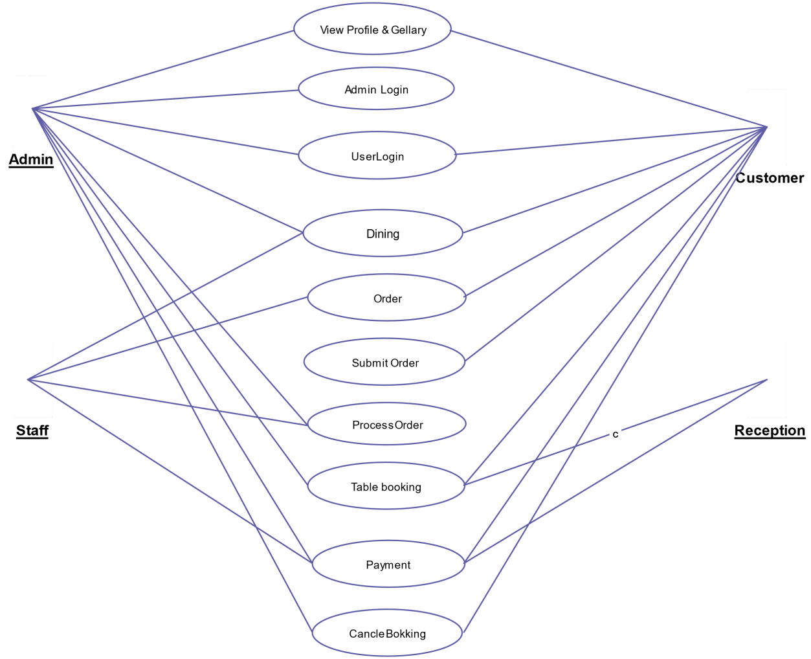

## Advantages

* **Improved Customer Experience:** Faster service with accurate orders, leading to increased customer satisfaction.
* **Data-Driven Insights:** Provides valuable data on sales trends, customer preferences, and inventory levels.
* **Enhanced Communication:** Facilitates better coordination between the kitchen and front-of-house staff.
* **Customization:** Allows easy updates to the menu, pricing, and promotions. **Disadvantages**
* **Technical Issues:** System crashes or glitches can disrupt operations.
* **Training Required:** Staff need training to effectively use the system.
* **Dependency on Technology:** Over-reliance on the system can be problematic during power outages or internet issues.
* **Data Security:** Risk of sensitive data being compromised if not properly secured.

## Future Scope

A café management system is essential for streamlining operations, improving customer service, and increasing profitability. As the food and beverage industry evolves, the future scope for such systems includes several promising trends and technological advancements.

## Conclusion

In conclusion, cafe management system is a valuable asset for cafe owners looking to streamline operations, enhance customer satisfaction, and boost profits. The project successfully integrates key functionalities such as order management, menu display, and customer interaction through features like the add-to-cart option. These systems not only streamline day-to-day tasks but also provide valuable insights through data analytics, helping café owners make informed decisions.

**Reference:**

* <http://www.bigresource.com/>
* [https://html.scribdassets.com/9926wjkoao7ovm85/images/37e1e484b173.png](https://html.scribdassets.com/9926wjkoao7ovm85/images/37-e1e484b173.png)